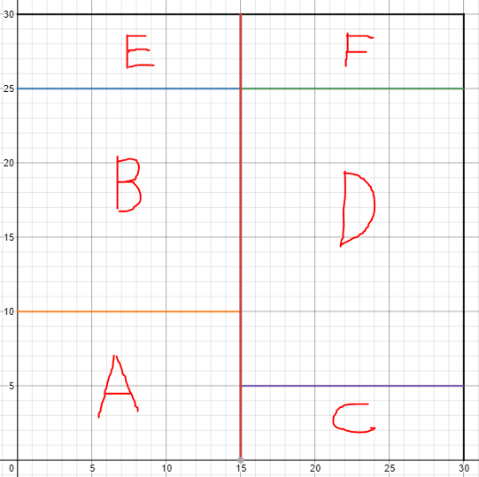



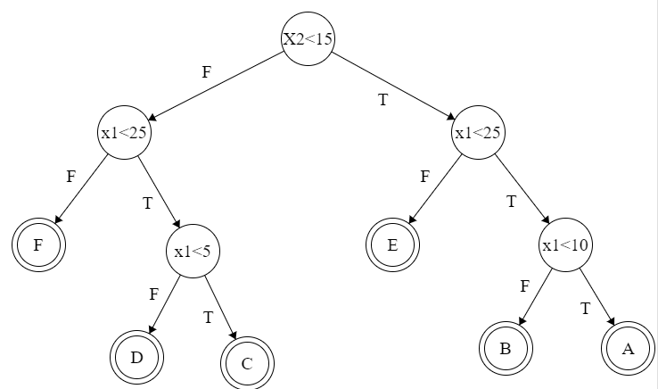

* 1. Harder: trying to find the most accurate by making a tree with the least necessary visits and redundant checks.



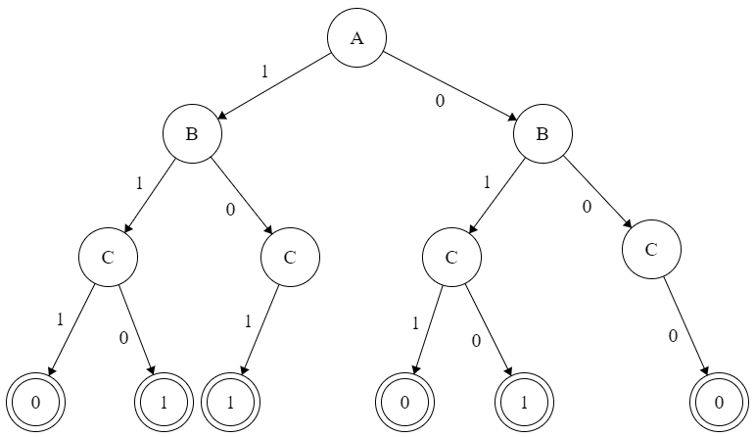

When A is 1 = 2/6 | When A is 0 = 1/6 = 0.959 - 0.918 = 0.041

When B is 1 = 2/6 | When B is 0 = 1/6 = 0.959 - 0.918 = 0.041

When C is 1 = 1/6 | When C is 0 = 2/6 = 0.959 - 0.918 = 0.041

$H(Y)= -\frac{3}{6}\log_{2}\frac{3}{6}-\frac{3}{6}\log_{2}\frac{3}{6} =0$

1. Corr is reduced because some samples could have been picked multiple times.

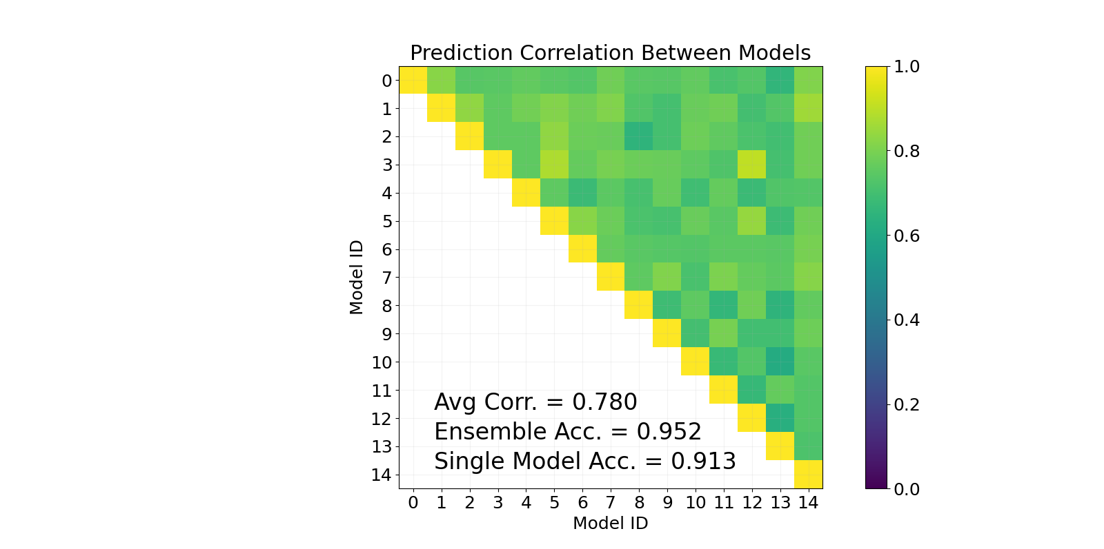

1. Setting 9 subsets to be picked by max_features during classifier

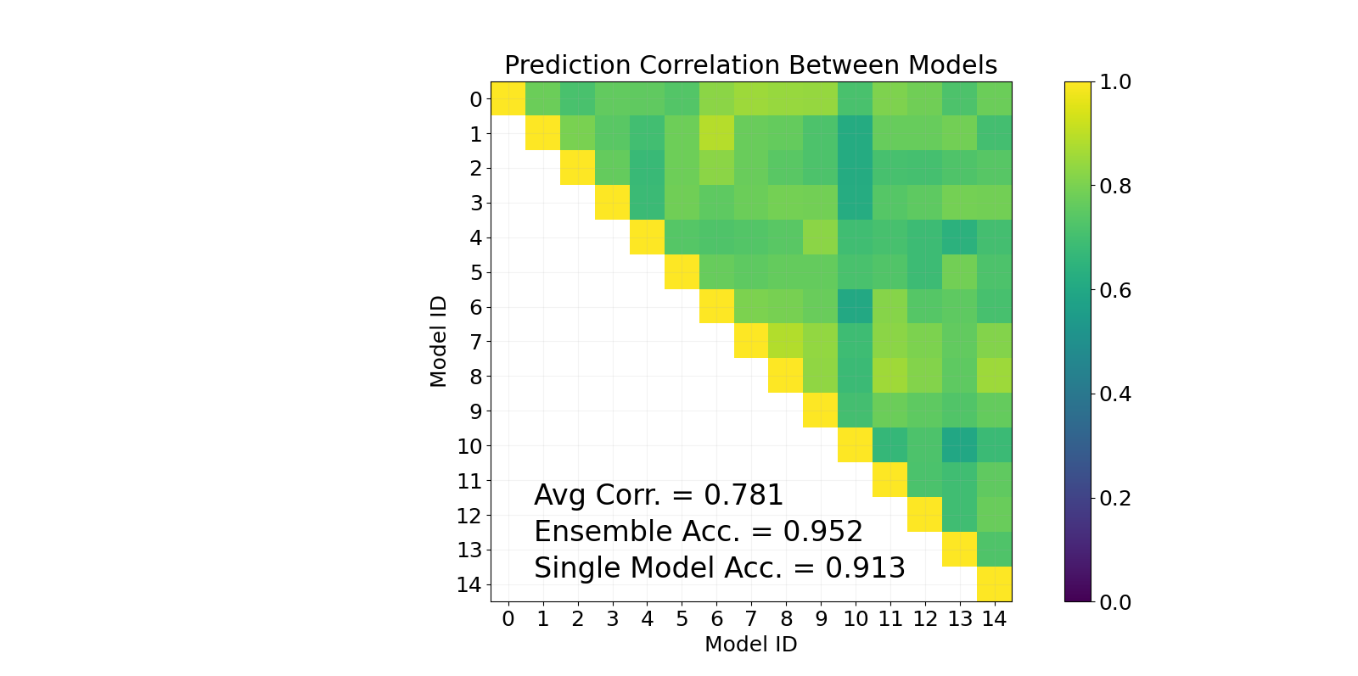



11/27 = 3.6 hours

1:00pm - 2:30pm

4:40pm - 5:30pm

11/28 = 2.3 hours

10:45am - 11:45am

5:10pm - 6:30pm

12/1 = 5.0 hours

4:50pm - 7:00pm

7:50pm - 8:30pm

10:10pm - 12:30am

12/2 = 3.1 hours

5:00pm - 6:00pm

7:20pm - 9:30pm

1. It is probably easy but I don't understand anything and I can't learn anymore. I failed this class and can't make a comeback at this point.
2. Alone, I asked a few questions to the professor. I tried to ask a friend for help but it showed me that I just don't know enough to try to finish this assignment.
3. 1%
4. I am too overwhelmed and uninterested in this subject to be proficient enough to pass it.